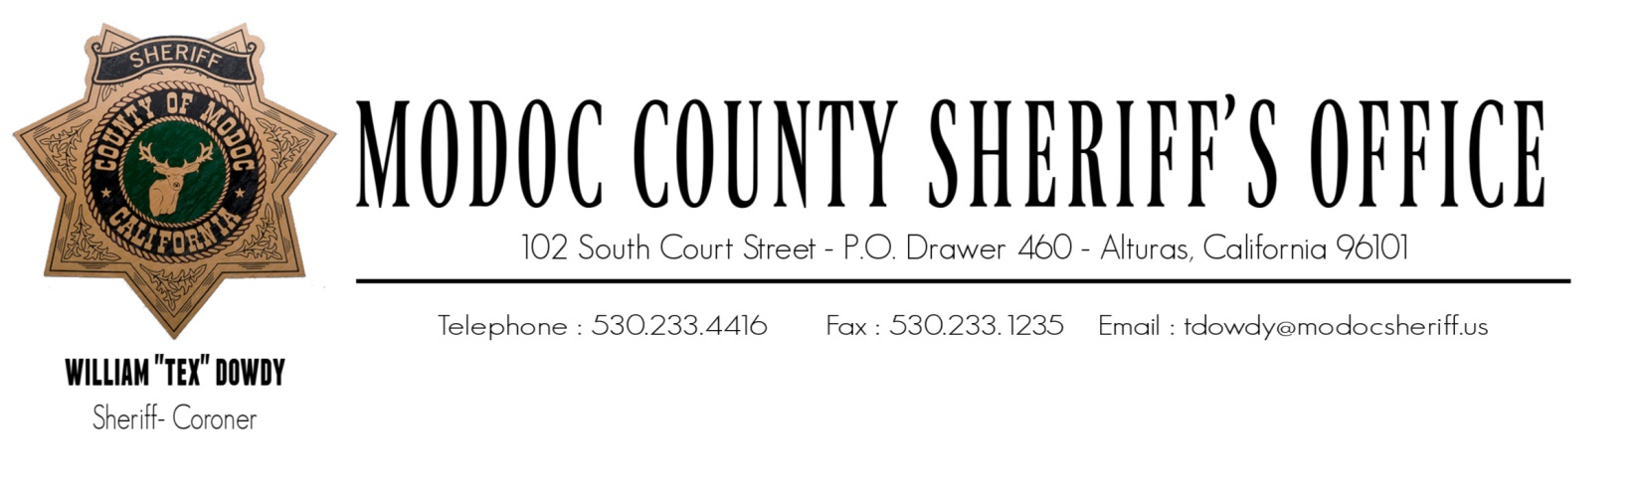
ONE NATION, UNDER GOD, INDIVISIBLE, WITH LIBERTY AND JUSTICE FOR ALL.
February 4, 2023

To: The Modoc County Board of Supervisors
204 S. Court Street, Suite 203
Alturas, CA 96101

RE: Presidential Executive Order (EO) 14074

NOTIFICATION TO BOARD OF SUPERVISORS AND LOCAL COMMUNITY

Modoc County Board of Supervisors,

On May 25, 2022, Presidential Executive Order (EO) 14074 “Advancing Effective, Accountable Policing and Criminal Justice Practices to Enhance Public Trust and Public Safety” was signed.

In accordance with EO 14074 (Section 12), State, Tribal, Local and Territorial Law Enforcement Agencies (LEAs) must:

- Notify their Civilian Governing Body (CGB) (i.e., City Council, County Government, or other local governing body) of its intent to request property from Federal sources (to include Federal funds or grants).
- Notify the Local Community of its request for property transfers, purchases from Federal funds, agencies, or subcontractors (including existing transfer contracts or grants).

The Modoc County Sheriff’s Office may request controlled property items from the Law Enforcement Support Office (LESO), or other Federal sources. This office is will not be requesting any controlled property items this year (2023).

This notification is also published on the Sheriff’s Office public website for Local Community access. Pursuant to EO 14074 (Section 12), this letter fulfills the requirement to notify the Civilian Governing Body and Local Community of this agency’s intent to request controlled property items from the Law Enforcement Support Office (LESO), or other Federal source.

William “Tex” Dowdy, Sheriff-Coroner

