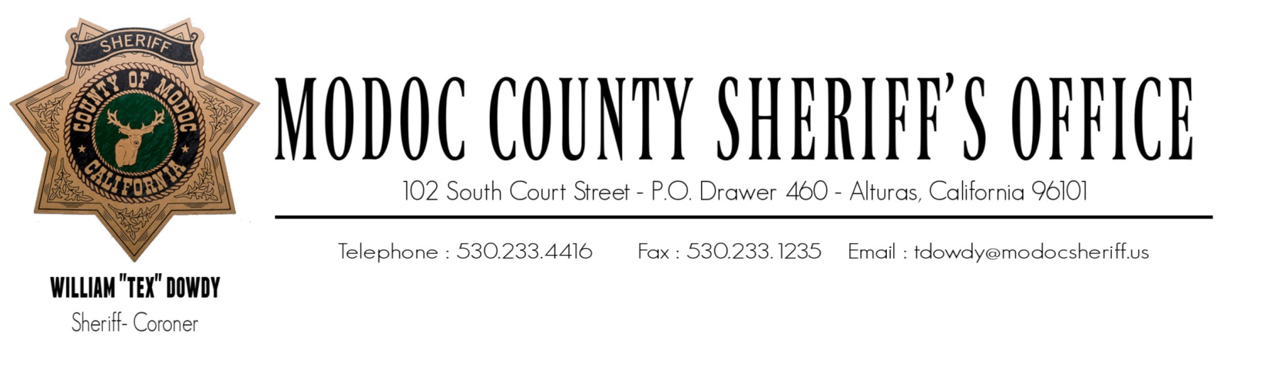
ONE NATION, UNDER GOD, INDIVISIBLE, WITH LIBERTY AND JUSTICE FOR ALL.
February 4, 2023
To: The Modoc County Board of Supervisors
204 S. Court Street, Suite 203
Alturas, CA 96101

RE: Military Equipment Use Annual Report (2022)

NOTIFICATION TO BOARD OF SUPERVISORS AND LOCAL COMMUNITY

Modoc County Board of Supervisors,

On January 10, 2023, the Modoc County Board of Supervisors passed and adopted a Military Equipment Use Policy for the County of Modoc.

- It is the policy of the Modoc County Sheriff’s Office to submit an annual military equipment report to the Modoc County Board of Supervisors that addresses each type of military equipment possessed by this Office.
- It is the policy of the Modoc County Sheriff’s Office to make each annual military equipment report publicly available on our public website for as long as the military equipment is available for use.
- It is the policy of the Modoc County Sheriff’s Office that the annual military equipment report, at a minimum, include the following information for the immediately preceding calendar year for each type of military equipment.

Military Equipment Possessed
- Mine Resistant Ambush Protected Vehicle (MRAP)
The purpose of the MRAP vehicle is to provide ballistic protection to law enforcement and citizens from gunfire. The armored vehicle stops rifle rated rounds including, .50 caliber, which is commercially available and beyond the protection level of shields and personal body armor possessed by this office. The MRAP vehicle is also used for rescuing law enforcement and citizens during a critical incident or natural disaster.
- Non-Armored Humvee Ambulance
The Non-Armored Humvee Ambulance is used to transport equipment and personnel during a critical incident or natural disaster.
- Light Tactical Vehicle
The purpose of the Light Tactical Vehicle is to provide ballistic protection to law enforcement and citizens from gunfire. The vehicle is designed to stop small arms, such as handguns and small caliber rifle rounds, which is beyond the protection level of shield and personal body armor possessed by this office. The Light Tactical Vehicle is also used for rescuing law enforcement and citizens during a critical incident or natural disaster.

How Military Equipment Was Used
- Mine Resistant Ambush Protected Vehicle (MRAP)
During 2022, the vehicle was used for display at public events, and training purposes, which includes driving, deploying from and rescue techniques.
- Non-Armored Humvee Ambulance
Not used for any purpose.
- Light Tactical Vehicle
Not used for any purpose.

Complaints/Concerns Received
None on any of the equipment listed in this report.

Violations of Military Use Policy/Actions Taken in Response
Policy was not adopted until January 2023. In accordance with current policy, there were no violations of policy during 2022.

Total Annual Cost, Including Acquisition, Personnel, Training, Transportation, Maintenance, Storage, Upgrades
Less than $300 for all equipment listed in this report. It is anticipated that the Modoc County Sheriff’s Office will spend general fund monies in 2023 for the following repairs and upgrades;

- MRAP Vehicle
$2,500 to replace (2) rear tires and add communications to the vehicle. We have the (2) tires which were also acquired through the Law Enforcement Support Office (LESO) prior to 2022.
- Non-Armored Humvee Ambulance
$1,500 to fix the brake system and add communications to the vehicle.
- Light Tactical Vehicle
$1,000 to replace batteries and add communications to the vehicle.

Quantity Possessed
In 2023, this office will not be requesting any additional controlled items from the (LESO), or other Federal sources.

Public Meeting
Within 30 days of submitting and publicly releasing this annual report, The Modoc County Sheriff’s Office will hold one well-publicized meeting for the general public to discuss and ask questions regarding this Annual Military Equipment Use Policy Report.

William “Tex” Dowdy, Sheriff-Coroner

